**HW 3**

**1.**

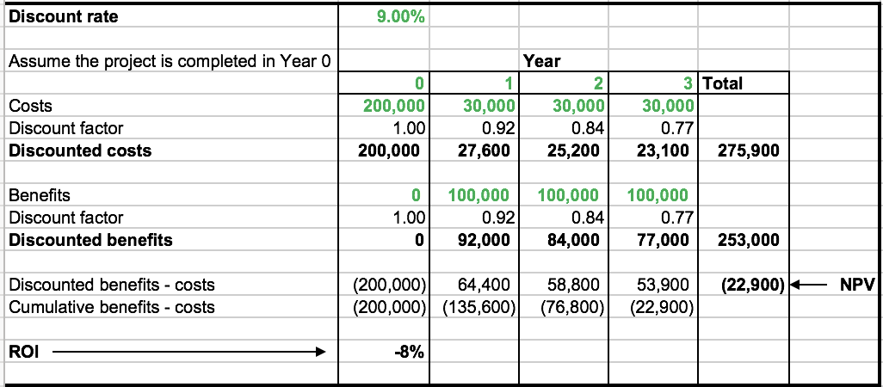

The Return on investment is -8% which means that investing in the project is not recommended. Also, since the NPV is (22,900) indicating that the payback will not be noticed within the given years and may be an additional investment in the 4th year may be able to make it as the payback period and provide with return on investment.

